### Installation

The basic wago will consist of the following modules as seen in the overview (see Figure 2‑34).

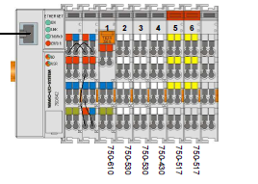

Figure 2‑34: PLC overview

#### PLC explanation and settings

In the following exploded views (see Figure 2‑35 and Figure 2‑36) you can see which fields are attached to which PLC slide. These settings suffice the mandatory rules as stated in MSC128(75).

These fields are also described in the Product description v1.2 and can be subdivided in the following:

6* WAP 1st stage

4* WAP 2nd stage

4* WAP 3rd stage

6* Timer reset button

1* Stage 1 alarm out to VDR

1* Stage 2 alarm out to VDR

1* Stage 3 alarm out to VDR

1* Common failure alarm out

1* in BNWAS on/off

1* in BNWAS auto

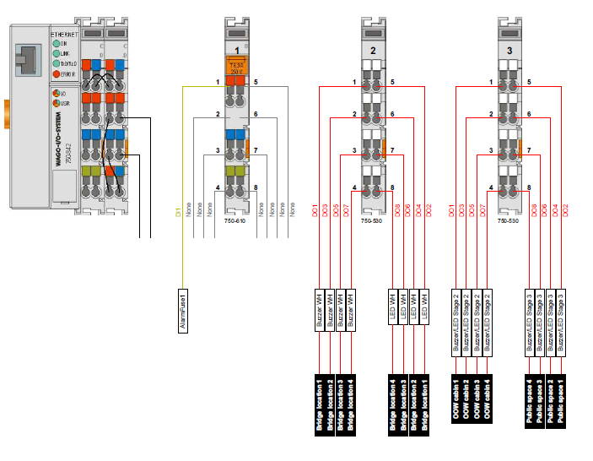

Figure 2‑35: Exploded view 1

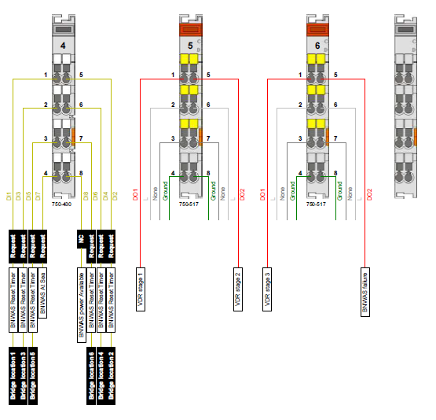

Figure 2‑36: Exploded view 2